ATS Feedback & Enhancement Requirements

1. MRF & JD Management
1. Hold Option in MRF Submission --L04
Add a “Hold” option in the MRF submission workflow, along with:
- Approve Request
- Reject Request
- Hold Request
Improve the UI for the approval alert. Instead of displaying an error message, it should state:
“MRF has already been approved by the CEO/CHRO [Name].” --N32

2. Position Applied For – Search & Type Option
In the Candidate Form, under “Position Applied For,” provide both Search and Type options. --N18

3. JD Date & Version Identification --N19
Add a date/version against each JD so that the recruitment team can identify the latest JD linked to an MRF, especially when similar JD names exist.
- If there is no MRF, the recruitment team should have the option to modify/add the date displayed against the JD to identify the most recent version.

4. Bulk/Individual Profile Upload & JD Tagging (Most important) N14-N15
Profiles uploaded through:
- Excel/bulk upload
- Individual profile upload
should be automatically tagged against the selected JD and should be available for JD-based filtering.

5. JD Filtering & Matching Profiles N1- N12
JD filtering should display profiles that match the selected JD criteria only.
All profiles should be displayed in descending order based on their match criteria/rating. Result is still not upto the mark.

Incorrect/Low-Relevance Profile Matching
Why is a QA Automation .NET profile appearing with a 6.13/10 (High Match) rating when it does not appear to match the required criteria?
In some cases, such profiles receive higher ratings than profiles that actually meet the JD requirements. The matching logic should be reviewed to ensure that the rating accurately reflects the mandatory JD criteria.

Fresher Profile Rating
Fresher profiles that fall outside the defined experience criteria should receive a relatively lower match rating. The rating should appropriately reflect the mandatory JD criteria.
6. Candidate Screening & Pipeline
1. QA Automation Tagging --N20
The QA Automation tag is not available in Candidate Screening, although it is available in the Candidate Pipeline when we tested in staging requirment.
Please make the tagging options consistent across both sections.
2. Moving Candidates to a JD/Position
Candidates cannot currently be moved:
- From Search Candidate to a specific JD/position
Additionally, Keyword Search does not display the candidate’s email ID and contact number, and there is no option to move the candidate to the required stage. Please note “Location” has to be perfect match .
7. Flexible Interview/Assessment Stages-L01-L03
Can the system provide an option to skip stages when required?
For example:
- HR Screening → Evalground Assessment
- HR Screening → Functional Round
- Assessment → CEO Round
The workflow should allow authorized users to skip a stage based on recruitment requirements.
The skipped stage should also be re-opened/completed later if required.
For example, if the Evalground test is skipped due to a weekend walk-in and Tech 1 is scheduled, the Evalground assessment should be allowed to be conducted later.

8. Keyword Search & Filtering-N01
Keyword filtering/search should display the following candidate details:
- Candidate Name
- Email ID
- Contact Number
This will make it easier for the recruitment team to identify and take action on candidates.
Currently, only the contact number in the Skills section is providing an exact match.

9.Zeko Interview – Contact Number & Reminder -N22
The Zeko platform provides an option to capture the candidate's contact number, and a reminder is sent to the given contact number once the interview is scheduled.
Please consider having a similar functionality in the ATS as well.

10.Interviewer & Interviewee Visibility-N23
Currently, it appears as an Interviewer email during scheduling.
Instead, it should clearly mention:
Interviewer & interviewee email

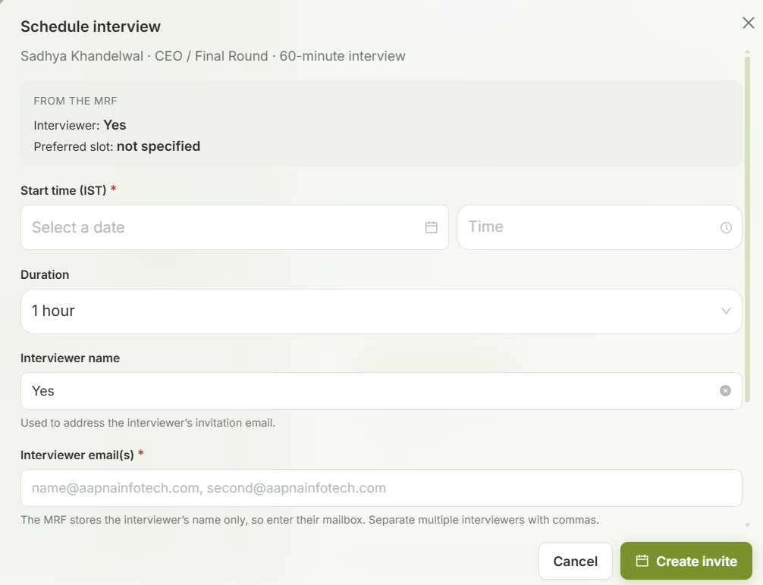
11. JD Attachment to Candidate (most important) -N17
When a candidate is tagged against a JD and selected/shortlisted for the next stage in the pipeline, an automatic email is sent to the candidate.
The JD should also be attached to this email.
Candidates may apply for multiple roles, so it is important that they have the opportunity to review and understand the relevant JD thoroughly before proceeding to the next stage.
12. CEO Round – Optional Stage-N24
The CEO Round should also be optional, similar to the Client Round.
In most cases, only CEO approval is required, while interviews are conducted for specific cases where required.
Therefore, the system should allow the CEO Round to be enabled or skipped based on the recruitment requirement.
Matching & Score analysis takes too long to upload .please note data is less now, it will be huge later.

